**Monitoring Remote Hosts**

* Remote Checks are usually used in the combination of Nagios plugins package that use either SSH or Nagios Remote Plugin Executor (NRPE)
* Monitoring over SSH
  + Install nagios plugins on the remote servers
  + Nagios offers a check_by_ssh plugin that takes the hostname and actual command to run on the remote server
  + switch to nagios user
  + Configure SSH Connection by using ssh_keys

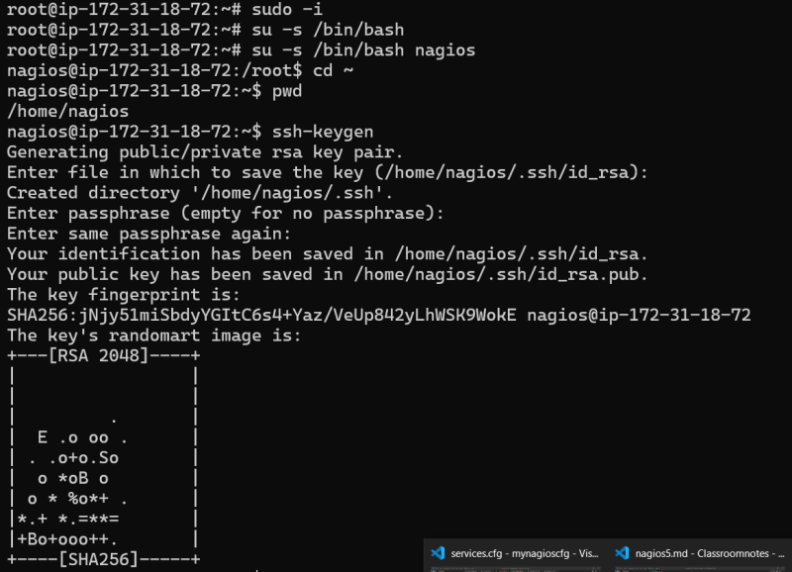

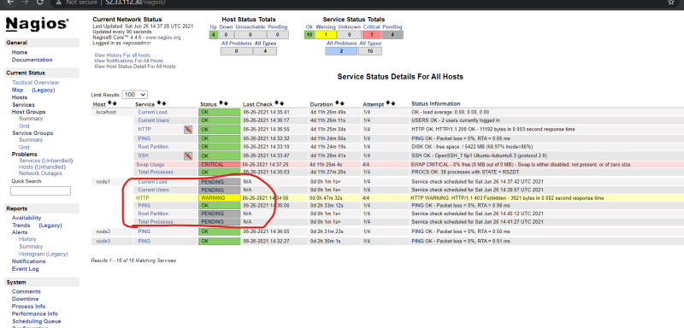

* Monitoring using NRPE:
  + overview

